COMPANY PROFILE

LTD.

SERVICES

INTEGRATED

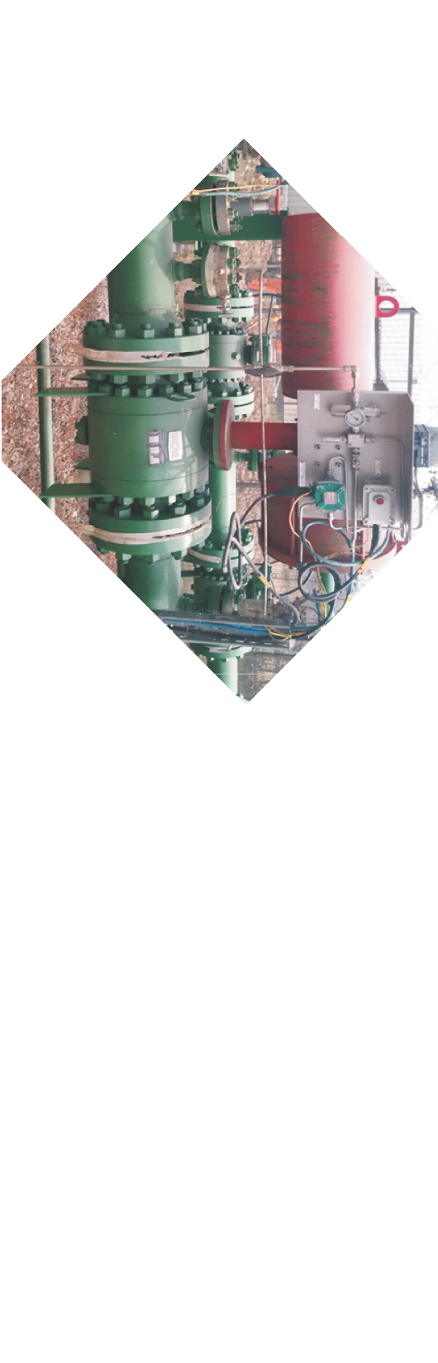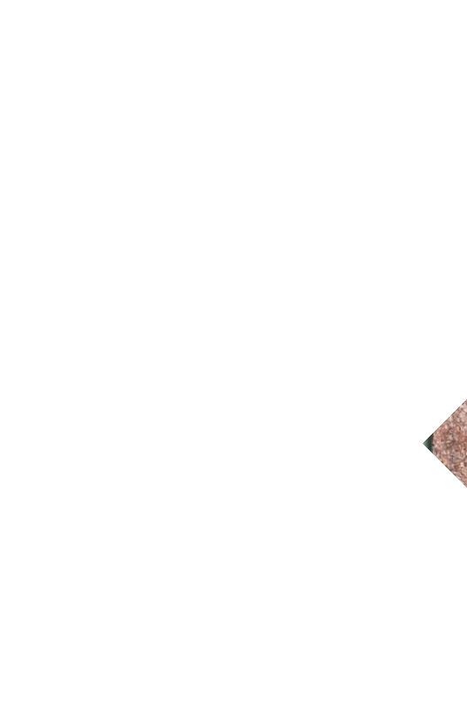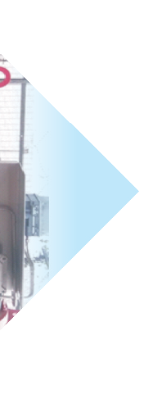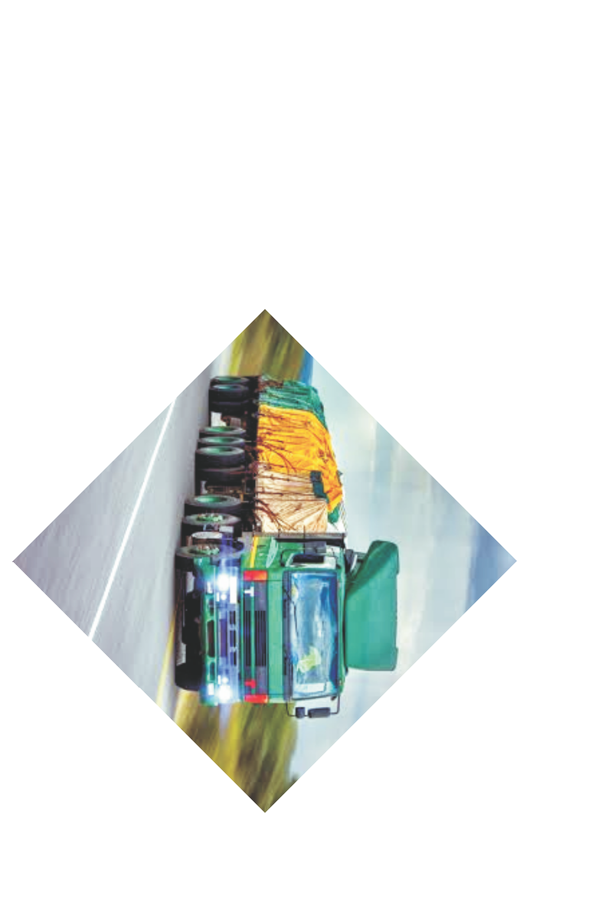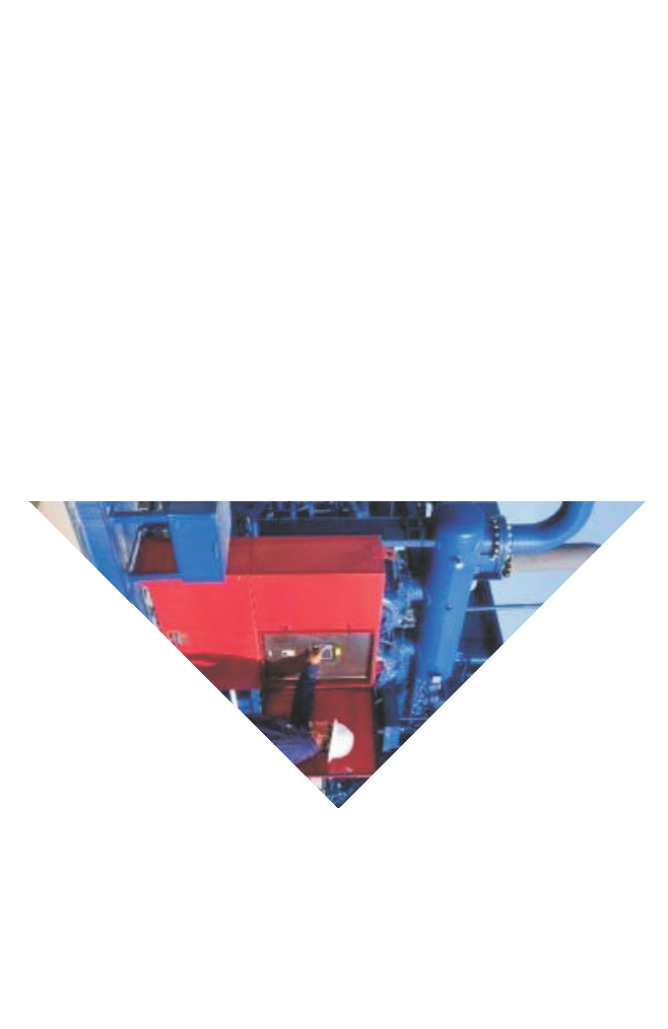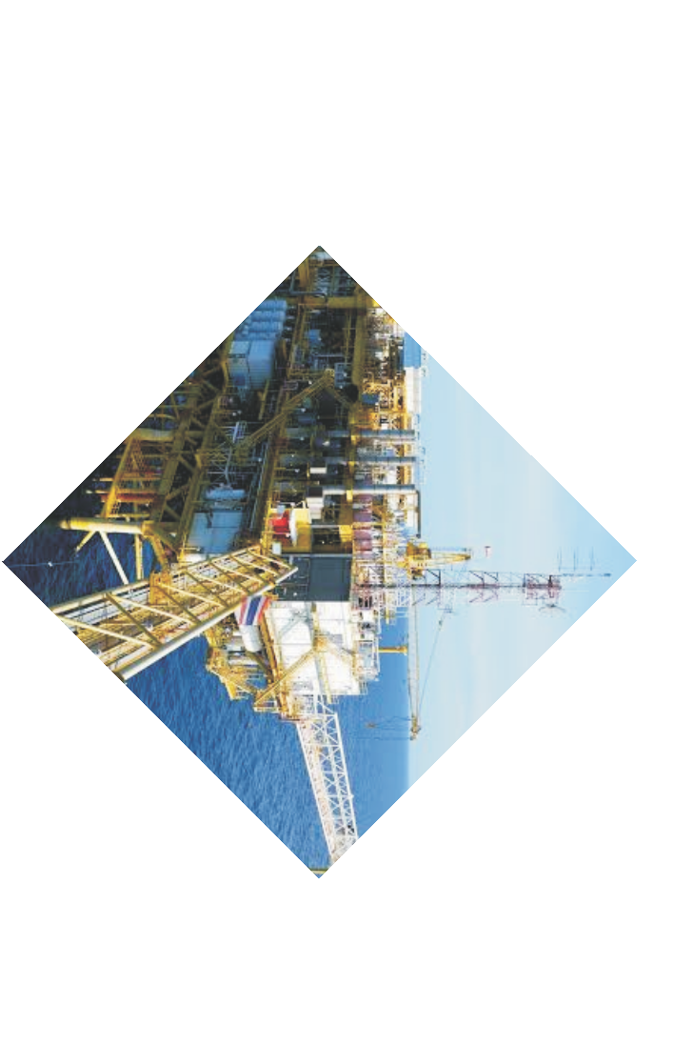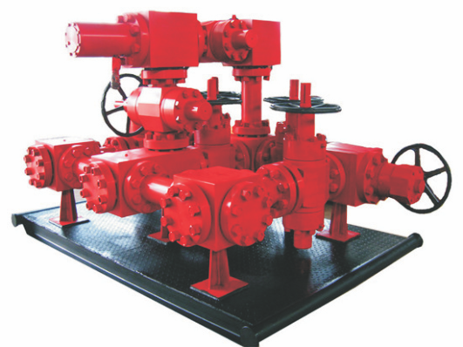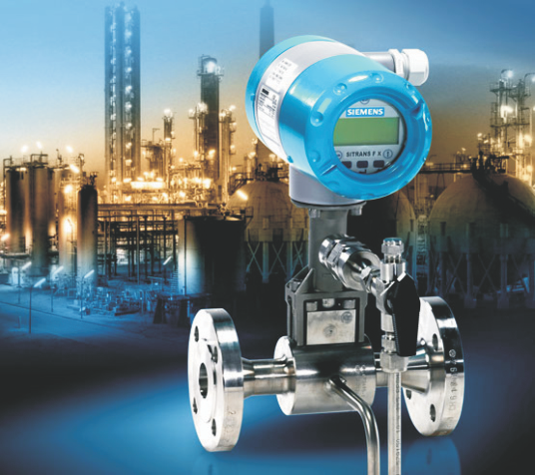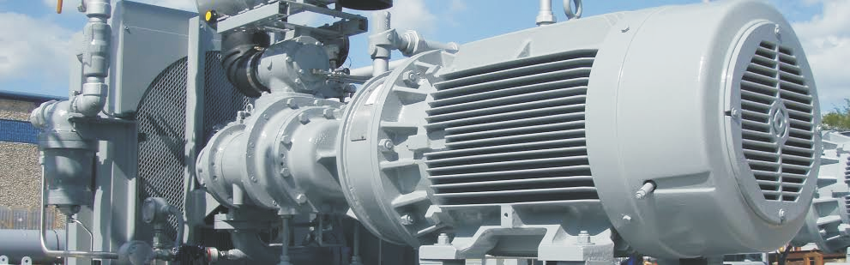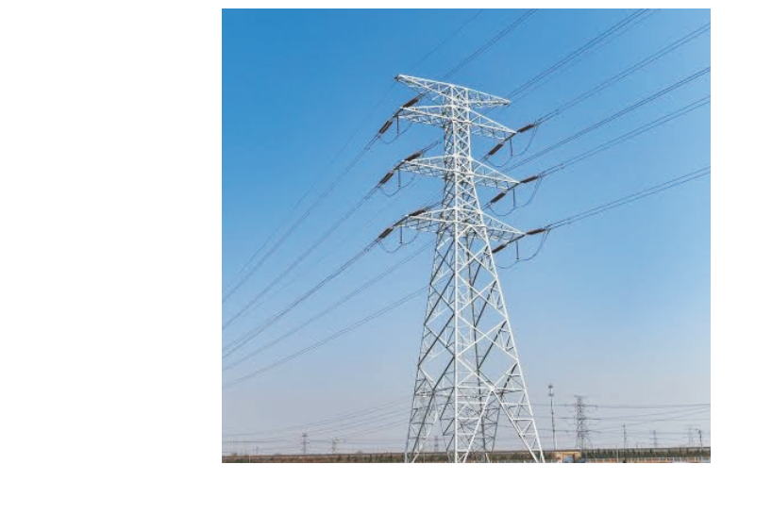

e c t i o n a l

Repairs

**ABOUT US**

**D I O K A I N T E G R AT E D S E R V I C E S LT D .** w a s established in 2007 and registered on 1st July 20211 as a limited liability company. The company was established to enhance coverage of all the engineering needs of oil, n o n - o i l , a n d g a s c o m p a n i e s ( s u c h a s design/construction and maintenance of mechanical, civil, electrical, instrumentations, procurement, and general services).

**DIOKA INTEGRATED SERVICES LTD.** has gained vast and quality experience in Engineering and Construction. The company’s scope of services is designed to the respective departments. The departments’ interest is to complement each other in technical abilities and so the actual services, which **DIOKA INTEGRATED SERVICES LTD.** can provide, are far greater than the sum of its constituent departments.

For this purpose, **DIOKA INTEGRATED SERVICES LTD.** can guarantee a number of dedicated, highly skilled Engineers and Constructors capable of providing custom-designed solutions for specific problems relevant to Oil and Gas exploration and exploitations as

Procurement and Supply Chain Management Electrical Installation and Sales of Electrical Materials

Rotating Equipment Specialists

F a b r i c a t i o n , C o n s t r u c t i o n a n d S Replacement

Corrosion Prevention And Monitoring

Chemical Injection

Valves, Pumps and Motors Maintenance, and Procurement

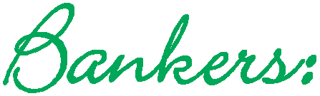

**UNION BANK FIDELITY ACCESS BANK**

**1**

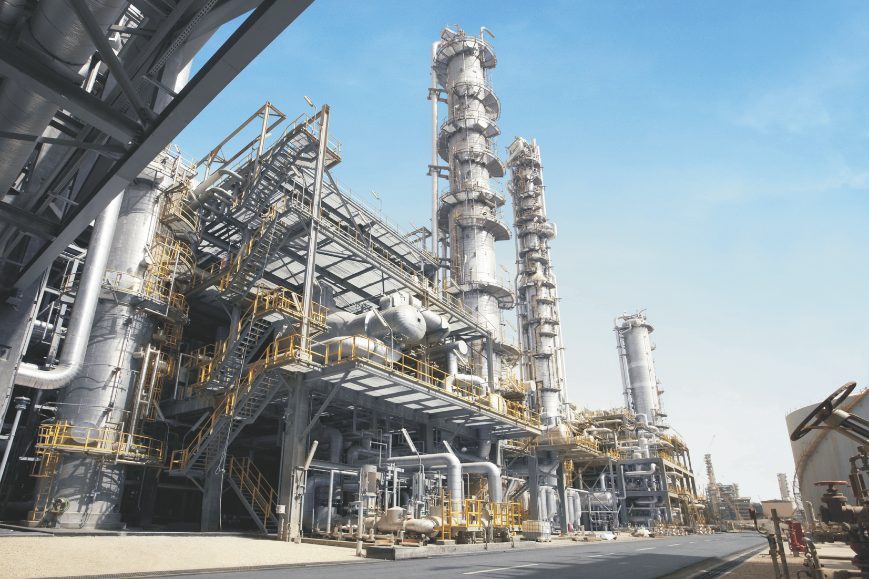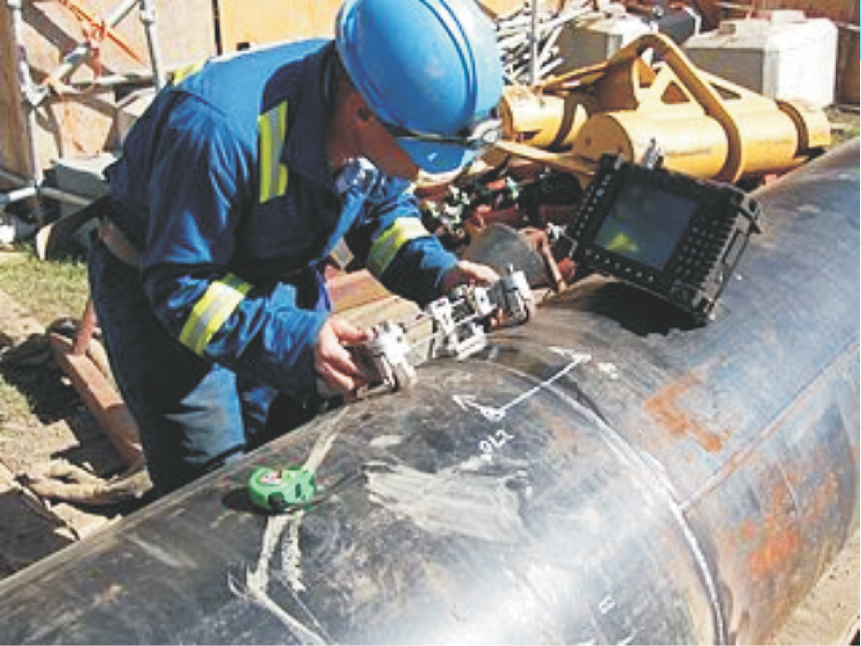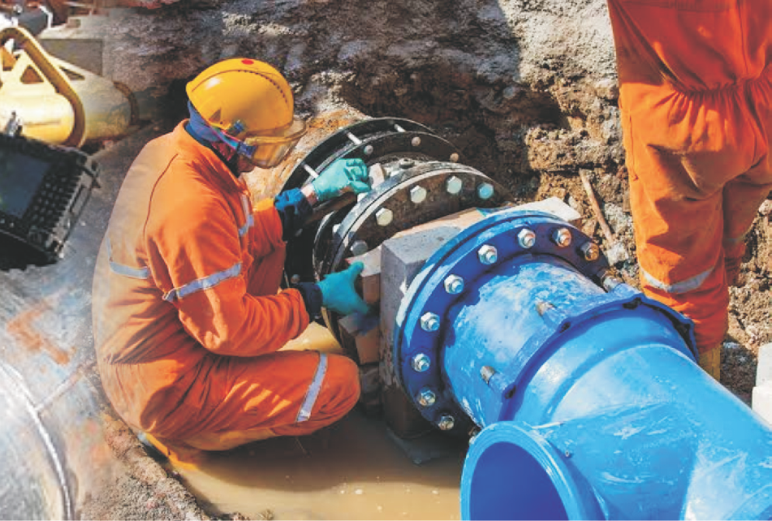

**2**

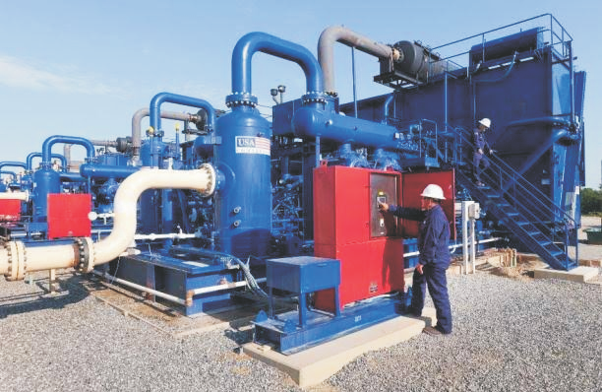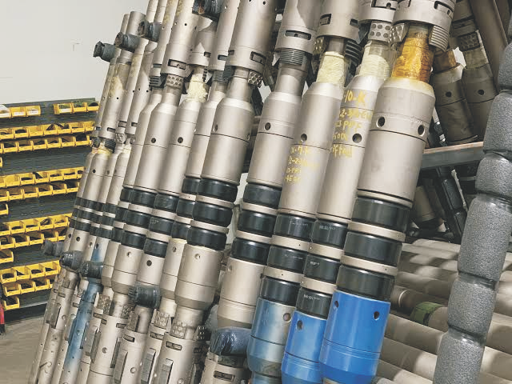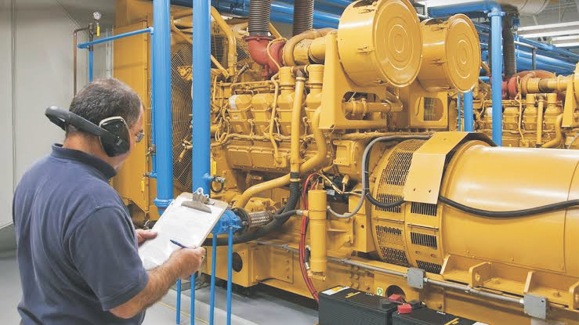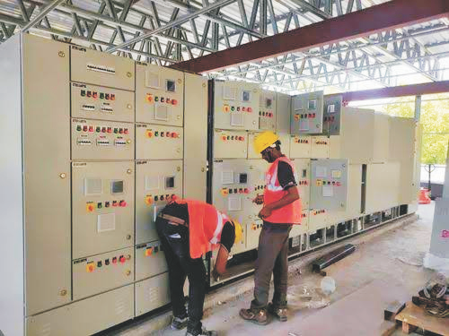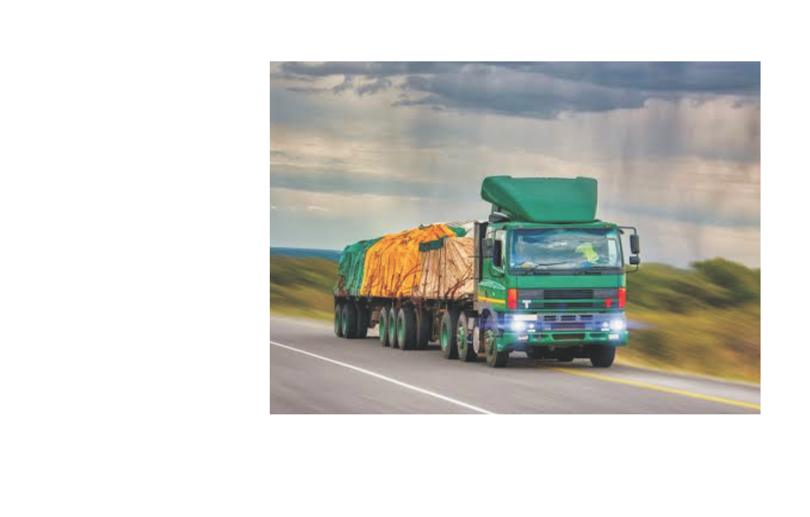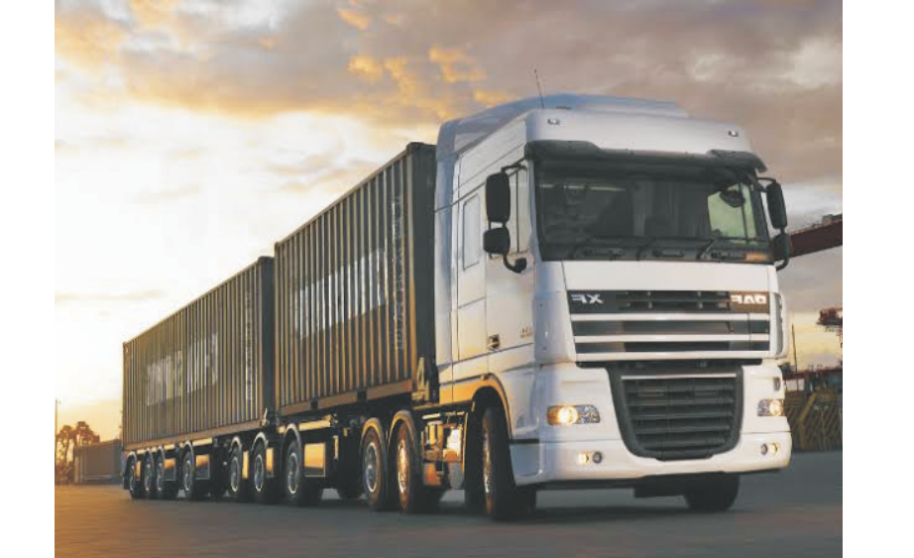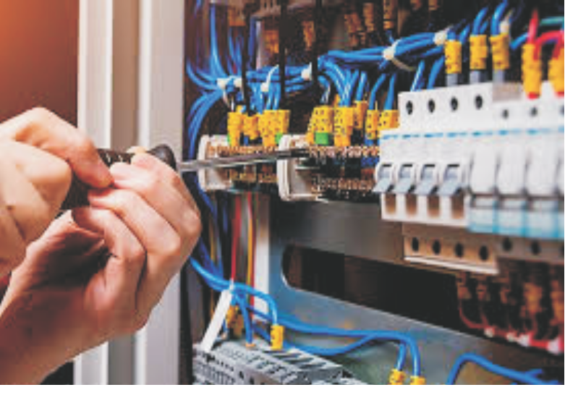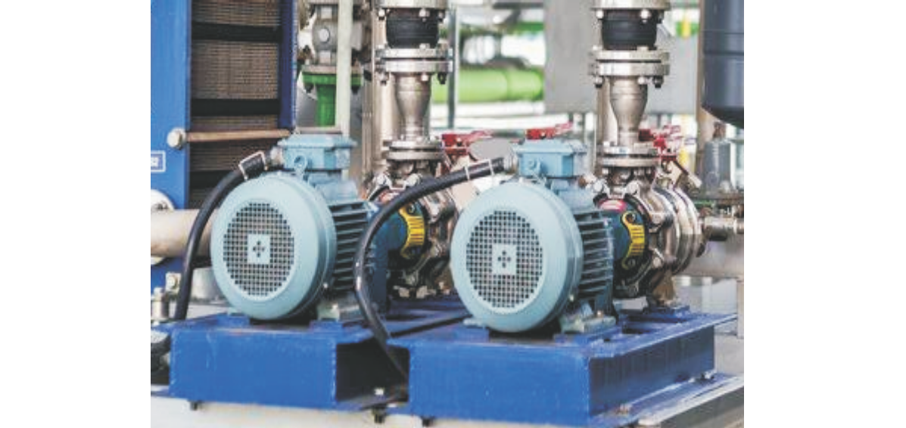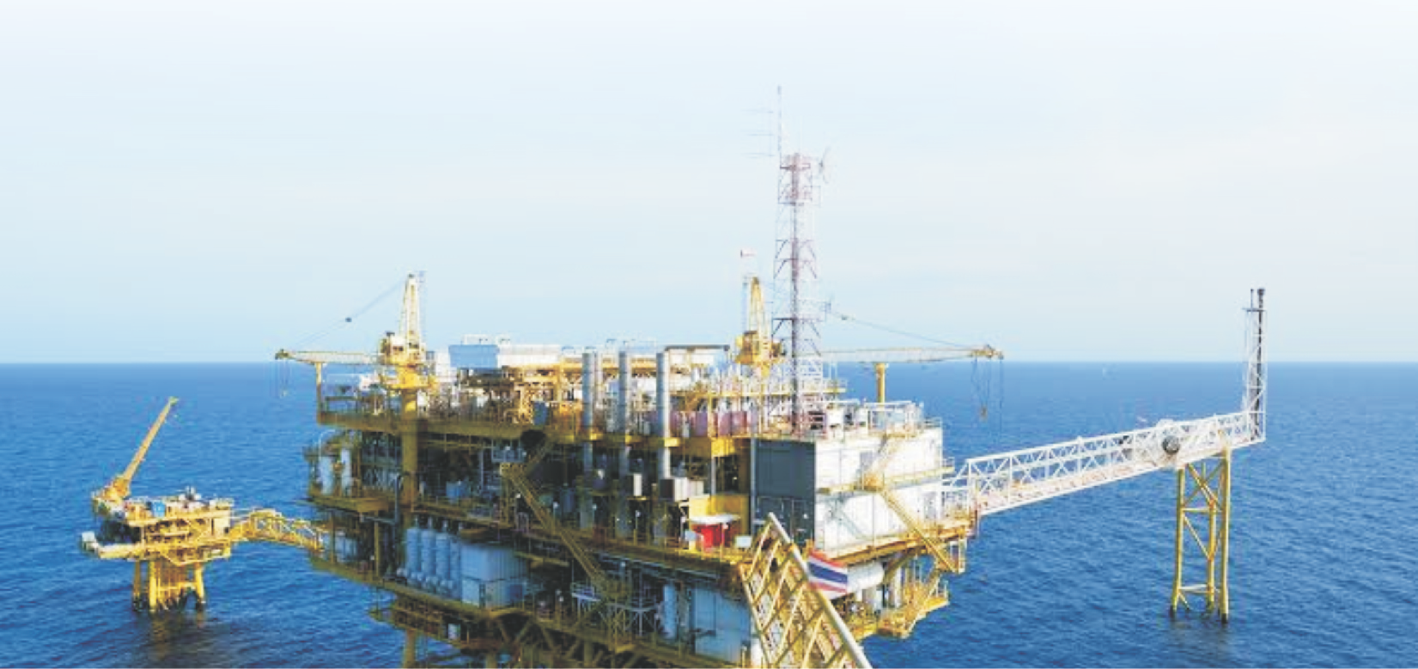

**3**

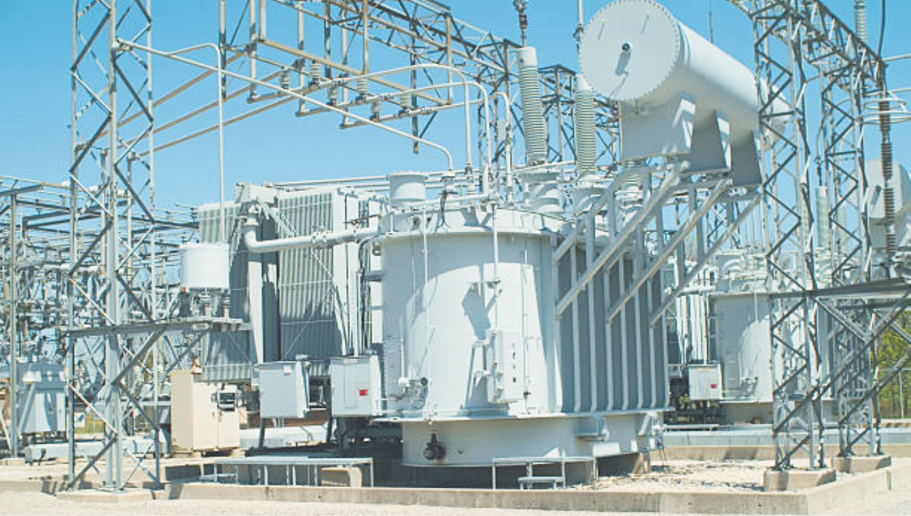

**4**

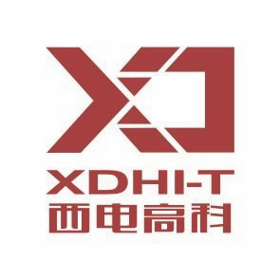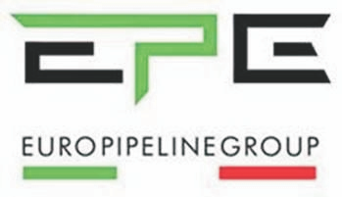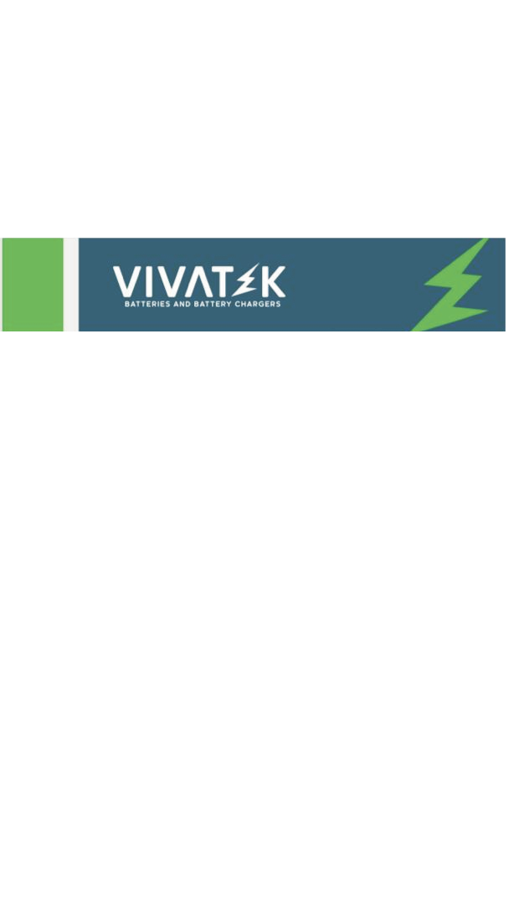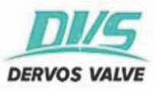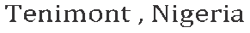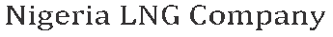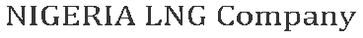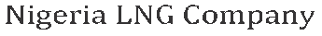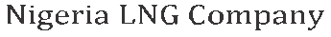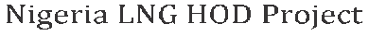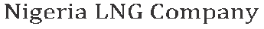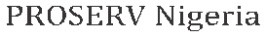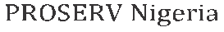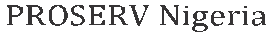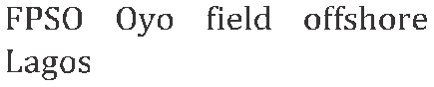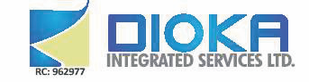

**SERVICES**

Procurement and Supply Chain Management Electrical Installation and Sales of Electrical Materials Rotating Equipment Specialists

Fabrication, Construction and Sectional Replacement

Corrosion Prevention And Monitoring

Chemical Injection

Valves, Pumps and Motors Maintenance, Repairs and Procurement

**NICAL PAR**

**TECH TNERS**

**PAST JOBS**

|  |  |  |  |  |  |
| --- | --- | --- | --- | --- | --- |
|  | |  | | | |
|  |  |  |  |  |  |
|  |  |  |  |  |  |
|  |  |  |  |  |  |
|  |  |  |  |  |  |
|  |  |  |  |  |  |
|  |  |  |  |  |  |
|  |  |  |  |  |  |
|  |  |  |  |  |  |
|  |  |  |  |  |  |
|  |  |  |  |  |  |
|  |  |  |  |  |  |
|  |  |  |  |  |  |
|  |  |  |  |  |  |
|  |  |  |  |  |  |
|  |  |  |  |  |  |
|  |  |  |  |  |  |
|  |  |  |  |  |  |

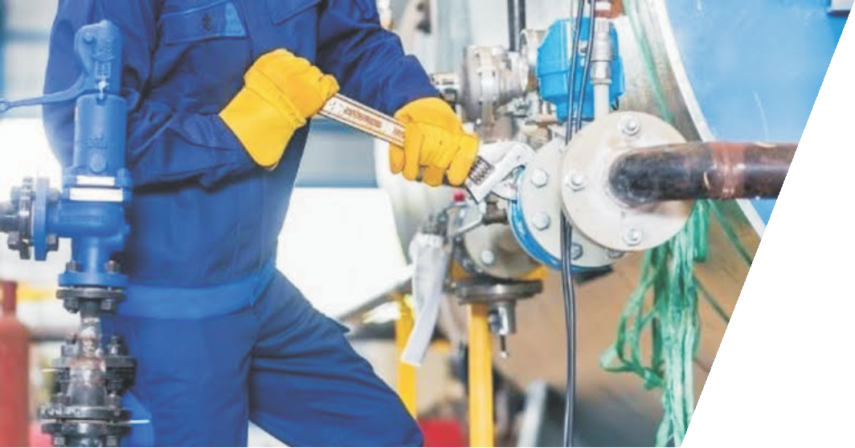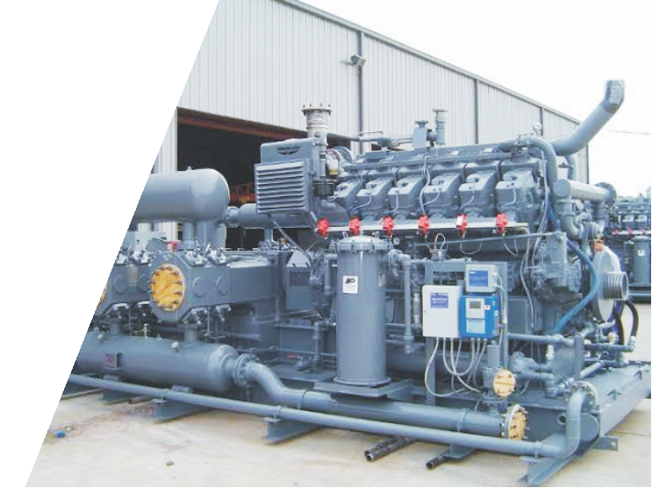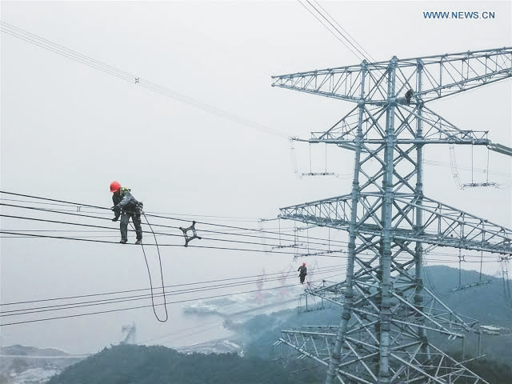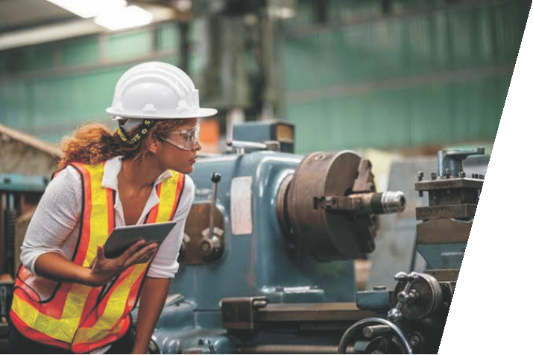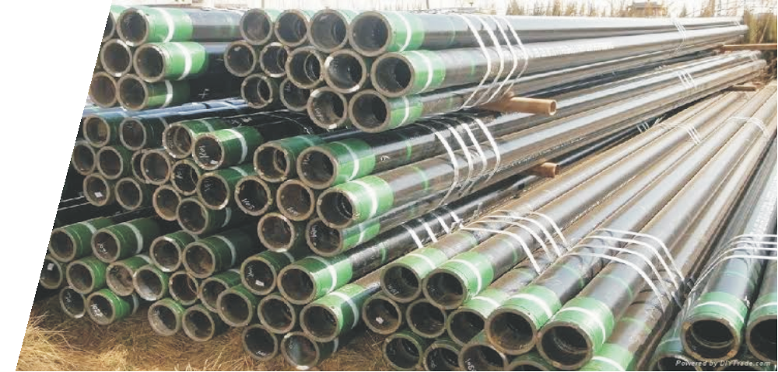

Our Clients:

**SPDC NLNG**

**BOUYGUES CONSTRUCTION SEPLAT**

**TECHNIMONT SAIPEM**

**BRUNEL ENERGY**

**GILDA NIGERIA LIMITED NIGERIAN AIRFORCE**

**UNITED PROJECT DEVELOPMENT COMPANY ZB JOINT VENTURES**

**TOTAL E&P NIGERIA LIMITED OANDO PLC**

**NNPC**

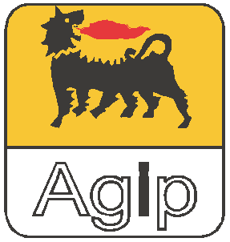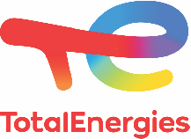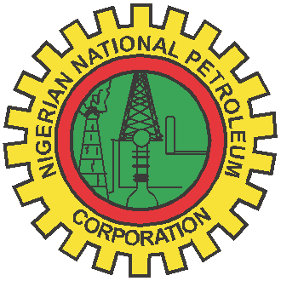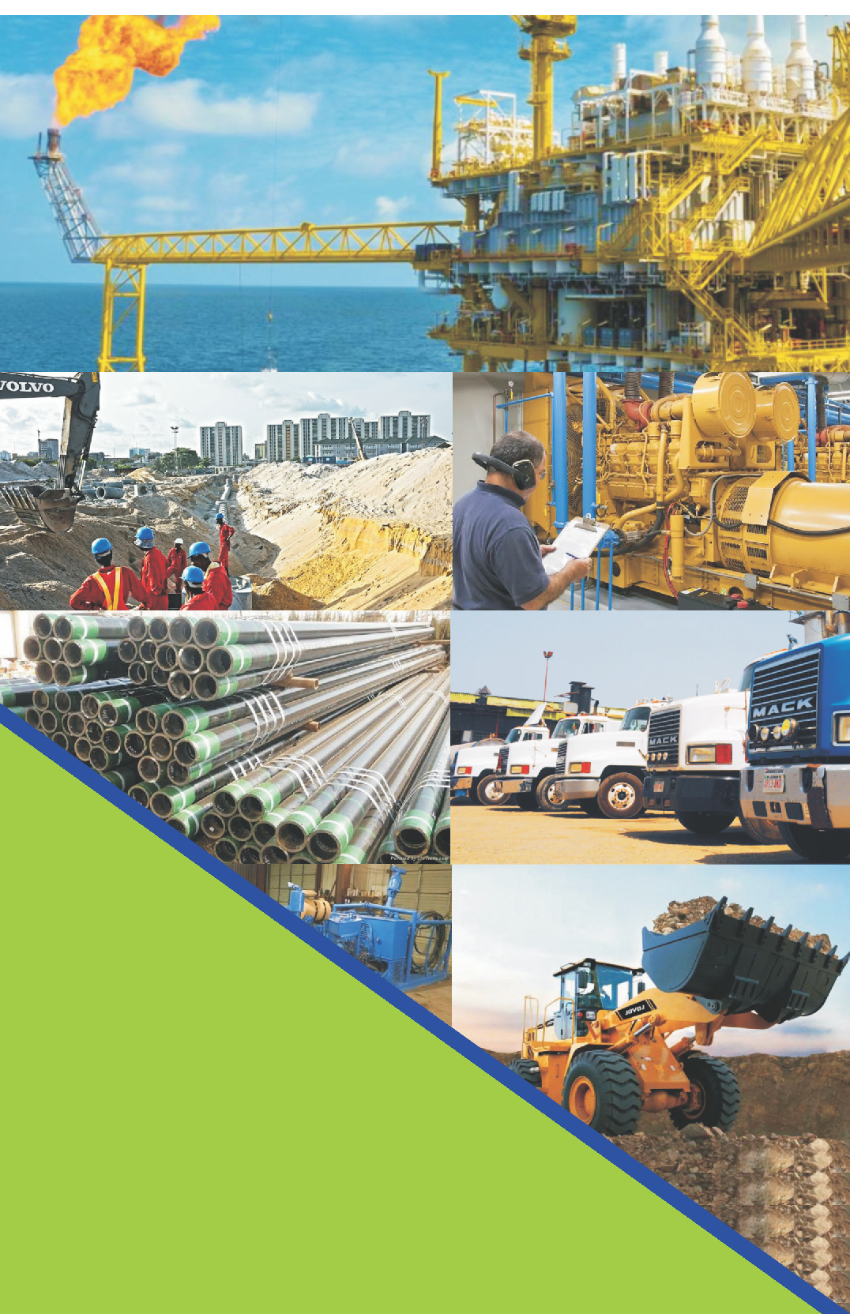

INTEGRATED SERVICES LTD.

NNPC Jetty Kokoama, Eastern By Pass, Port Harcourt, Rivers State.

1 Wals Close, off Peter Odili Road, Trans Amadi, Port Harcourt, Rivers State.

+2348037235195, +2348064655730,

+2348181371129

[eiwuoha@diokagroup.c](mailto:eiwuoha@diokagroup.com)om [www.info@diokagroup.c](mailto:http://www.info@diokagroup.com)om